Name: Will Graham

72TS

P2pChat

Contents

Problem Description 2

Defining the Problem 2

Needs and Objectives 2

Boundaries 2

Planning the solution 3

Gant Chart 3

Data Dictionary 3

Data flow Diagrams 3

Hierarchy chart 3

System Flowchart 3

Storyboard 3

Screen Designs 3

Implementing the solution 4

Algorithms and Coding 4

User Documentation 4

Final Package 4

Testing 5

References 6

# Problem Description

A platform allowing for secure file transmission between computers on a Local Area Network, without any connection to the World Wide Web, or any other external network, can be useful in areas with limited connectivity and communication is vital. Privacy, although not held in high regard by some, is also vital in communications, as it allows for trust between the developer and users of the software solution. As this solution is decentralised and open source, it is inherently more secure than proprietary solutions.

# Defining the Problem

## Needs and Objectives

|  |  |
| --- | --- |
| Needs | Objectives |
| Incorporate a means for connecting one client to another | Provide an area for user input so they can connect to one another |
| Provide a display showing the user their current IP address |
| Allow for a “Notes Area”, where a user can save addresses, as well as notes about their current conversation |
| Implement a local-IP only system |
| Implement a method for the user to select the ports they wish to use |
| Incorporate a safe method of communication | Incorporate basic encryption, by converting the string to a non-string format, and back to a string when received by the secondary string |
| Provide a multi-line display of the messages sent and received, with a clear button at the top. |
| Provide an area for the user to enter their message for the other client, and implement a system to deliver said message. |
| Incorporate a method for Attachments to be sent and received | Allow for Attachments (likely unencrypted) to be sent from one user to another over the network |

## Boundaries

The main boundary for this solution is that it is restricted to the local area network of the user(s). However, hypothetically, the solution can be used on the world wide web if the user(s) is/are willing to set up port forwarding on their routers.

# Planning the solution

## Gantt Chart: See attached excel file

## Data flow Diagrams

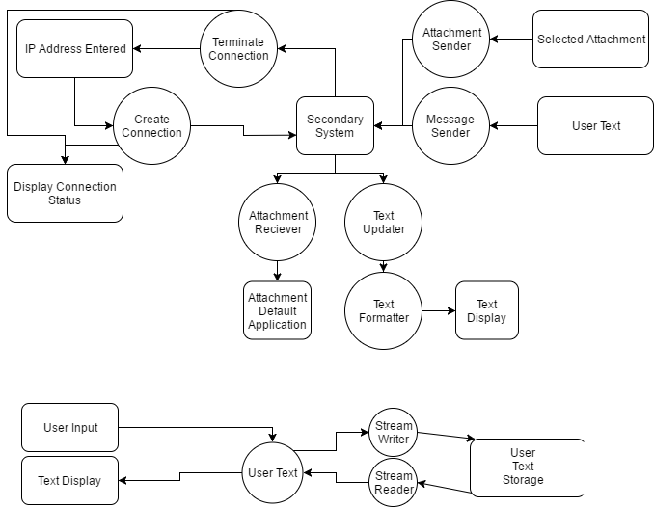

## Hierarchy chart

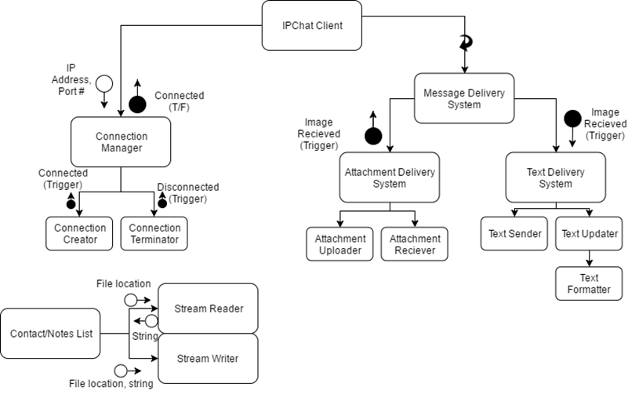

## System Flowchart

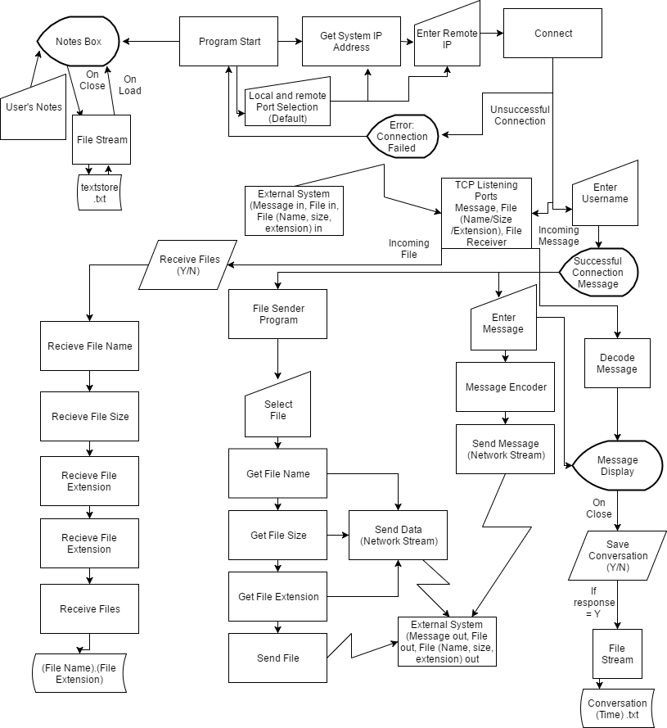

## Storyboard/Screen Designs

### On Load

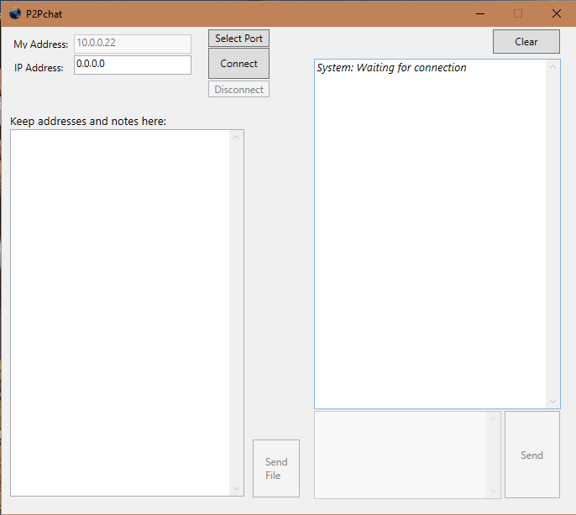

### When Connected

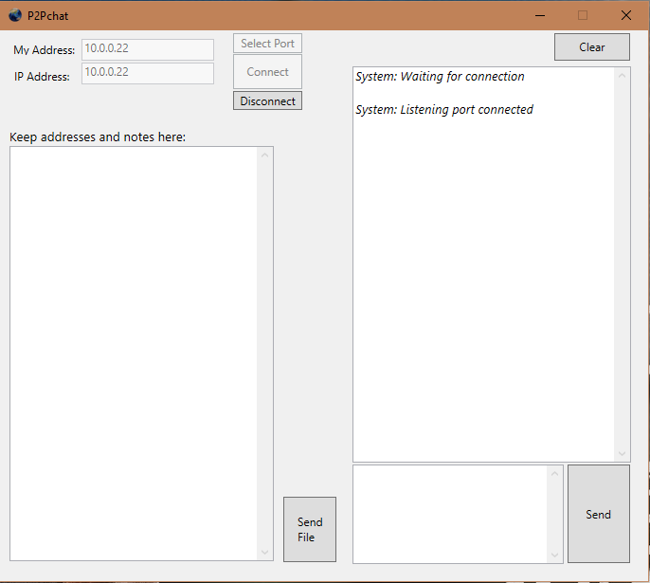

### When Message Sent/Received

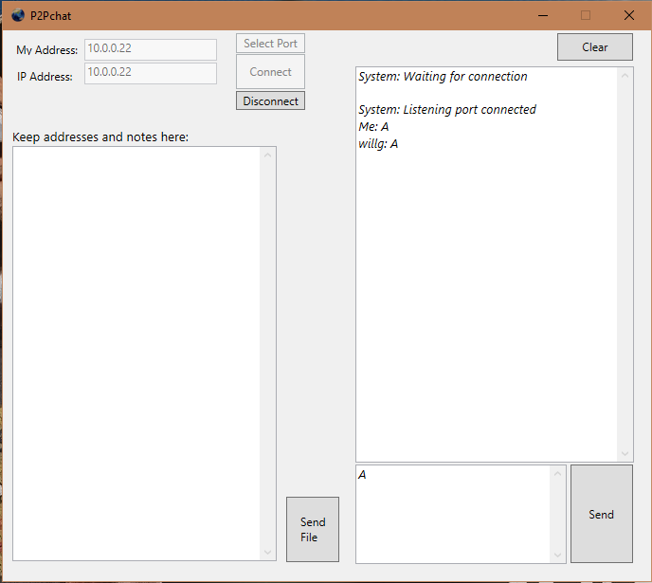

When Selecting File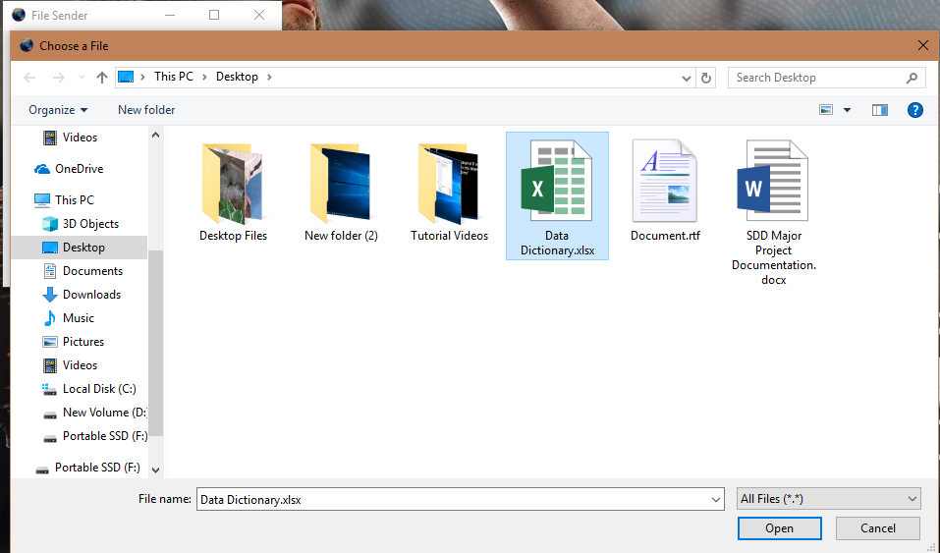

### 

### When File Selected

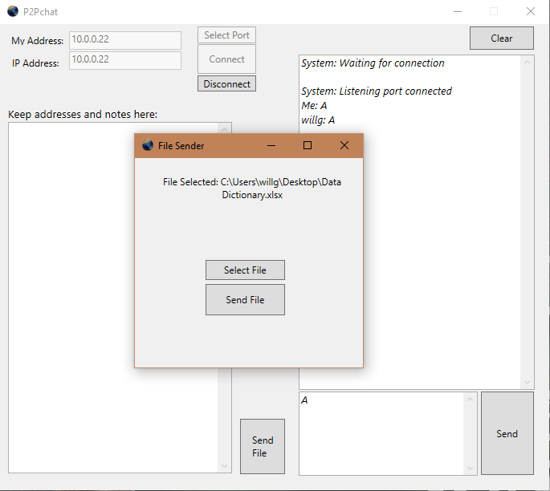

### When File Received/Sent

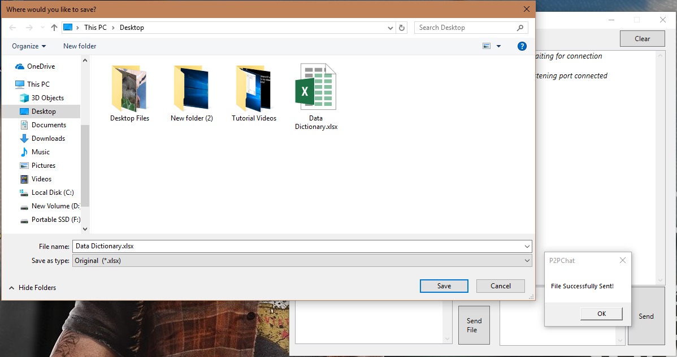

### When Disconnected/Changing Ports

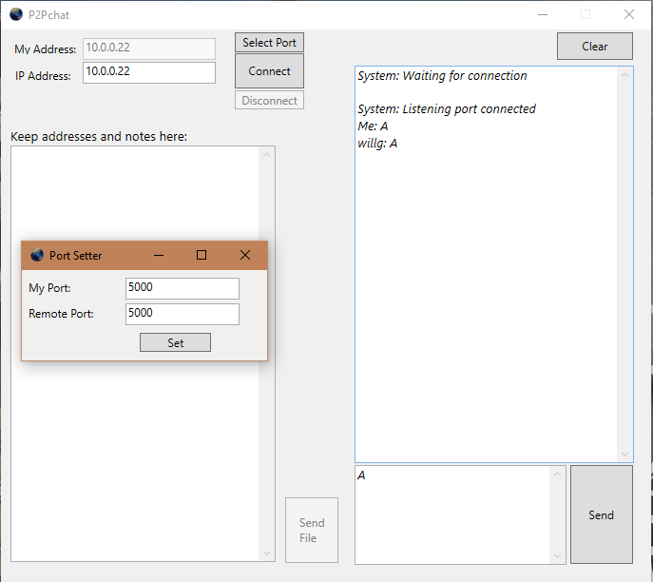

## Data Dictionary: See Attached Excel File

# Implementing the solution

## Algorithms and Coding

See main code on Github

## User Documentation

See Github

## Final Package

See Github

# Testing/Issues

## ~~Major: File sender producing distorted files (codename: “Wordsworth”)~~

~~Upon testing, it has been found that the file sending solution does not work properly, gaining extra bytes in transmission. In future iterations, a different method of sending files would be implemented, but due to restrictions in time and resources, cannot be fixed currently.~~

~~Possibly~~ Fixed: file Block Size was too large

## Intermediate: File sender only sends file on second attempt (codename: “Groundhog”)

When a file is sent using the file sender, the

## Minor: Tab key functionality not fully set up

The ability to use the tab key is hindered, as the selection is not set up in a linear fashion, instead jumping all over the window. In future iterations, this can be fixed relatively easily.

# References

Uses